EXP:4 | Virtual Private Server (VPS) Provisioning and Configuration
5/8/2026 | Virtual Private Server (VPS) Provisioning and Configuration

AIM
To provision a Virtual Private Server (VPS) using VirtualBox, install Ubuntu, configure network settings (IP Address, Subnet Mask, Gateway, DNS), and enable SSH remote access.

OBJECTIVES
- To understand the concept of Virtual Private Server (VPS).
- To create and manage virtual machines using VirtualBox.
- To install Ubuntu Server OS.
- To configure static network settings.
- To enable SSH remote access.

SOFTWARE REQUIREMENTS
- Oracle VirtualBox
- Ubuntu Server 22.04 LTS ISO (as specified in the lab manual)
- Windows/Linux Host System
- Internet Connection
- Terminal Access

THEORY
A Virtual Private Server (VPS) is a software-based server created using virtualization technology. It operates independently with its own operating system, storage, memory, and network configuration while sharing the physical hardware with other virtual machines. Virtualization enables efficient resource utilization and forms the foundation of cloud computing platforms.Network configuration parameters:

Parameter | Description
IP Address | A unique address assigned to a device on a  network.
Subnet Mask | Determines the network and host portions of  an IP address.
Gateway | Provides access to networks outside the  local network.
DNS | Converts domain names into IP addresses.
SSH | A secure protocol used for remote administration of Linux systems.

PROCEDURE

Step 1: Create Virtual Machine

Parameter | Value
Name | VPS-Server
OS Type | Ubuntu (64-bit)
RAM | 2 GB
CPU | 2 Cores
Storage | 20 GB
Attach the Ubuntu ISO, start the VM, follow the installation wizard, create a username and password, and complete the installation.

Step 2: Update Ubuntu
sudo apt update sudo apt upgrade -y

Step 3: Identify Network Interface
ip a
The practical execution identified the active interface as enp0s3 with the initial NAT address 10.0.2.15/24.
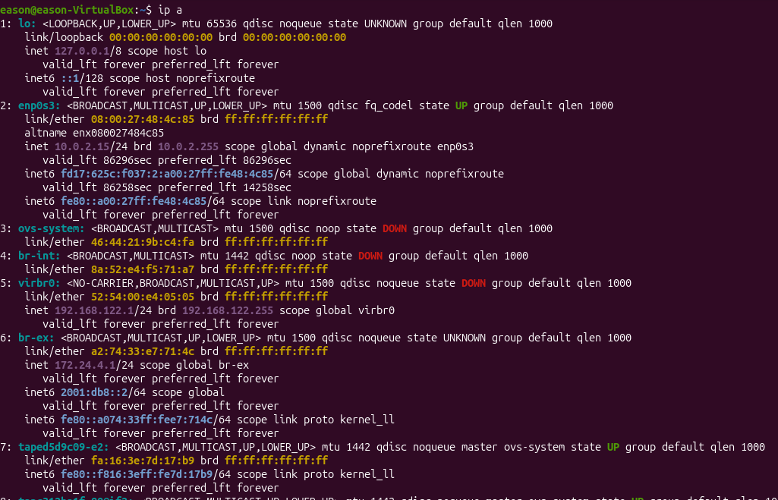
Figure 1. Network interface identification using ip a.

Step 4: Check Routing Information
ip route
The VirtualBox NAT gateway was identified as 10.0.2.2 through enp0s3.

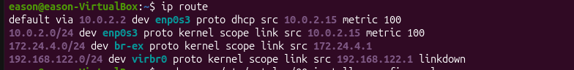
Figure 2. Routing table showing the VirtualBox NAT gateway.

Step 5: Configure Static IP
sudo nano /etc/netplan/00-installer-config.yaml
The following configuration was used for the actual VirtualBox NAT network:
network: version: 2 ethernets:
enp0s3: dhcp4: no addresses:
- 10.0.2.100/24
routes:
- to: default via: 10.0.2.2
nameservers: addresses:
- 8.8.8.8
- 8.8.4.4
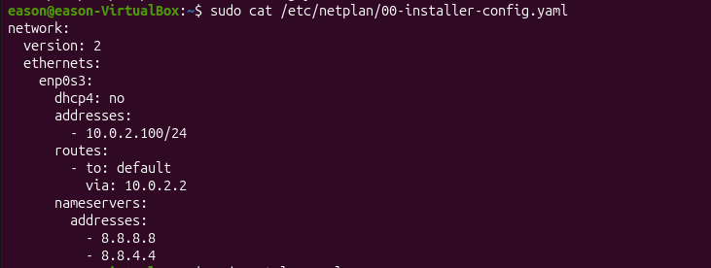
Figure 4. Saved Netplan configuration verified with sudo cat.

Step 6: Apply Network Configuration
sudo netplan apply
The command displayed a systemd-networkd reload warning because the desktop environment was not running systemd-networkd in the expected way. Subsequent routing and connectivity checks confirmed that the static configuration was nevertheless active.

Step 7: Verify Network Configuration
ip addr ip route
cat /etc/resolv.conf

The verified practical values were: interface enp0s3, static IP 10.0.2.100/24, default gateway 10.0.2.2, and DNS servers 8.8.8.8 and 8.8.4.4.

Step 8: Test Connectivity
ping -c 4 10.0.2.2
ping -c 4 8.8.8.8 ping -c 4 google.com
The gateway, Internet address, and DNS name were all reachable. The practical screenshots showed 4 packets transmitted and 4 received with 0% packet loss for the gateway and 8.8.8.8, and successful DNS resolution of google.com followed by successful replies.
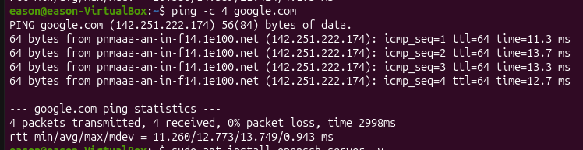
Figure 6. Internet and DNS connectivity verification.

Step 9: Install OpenSSH Server
sudo apt install openssh-server -y

Step 10: Enable and Start SSH Service
sudo systemctl enable ssh sudo systemctl start ssh sudo systemctl status ssh
The SSH service was verified as active (running), enabled, and listening on port 22.
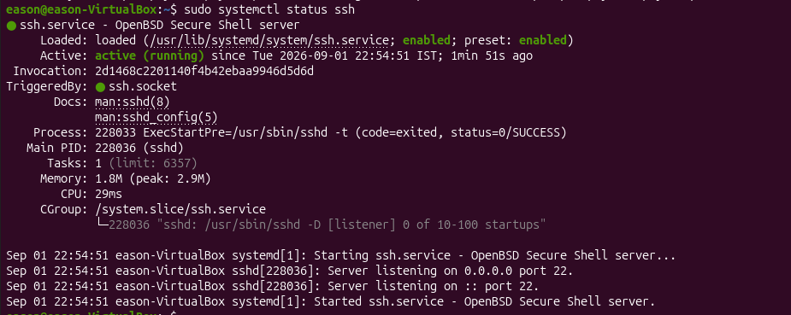
Figure 7. OpenSSH service status showing active (running) and port 22 listening.

Step 11: Remote SSH Login
ssh eason@10.0.2.100
The SSH connection was successfully established to the static IP address. The Ubuntu welcome message appeared after authentication, demonstrating successful remote login.
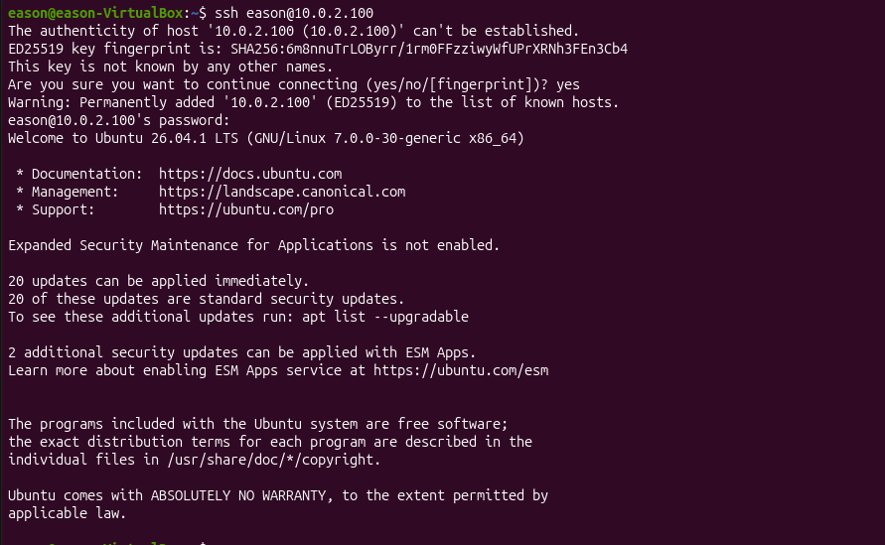
Figure 8. Successful SSH remote login to 10.0.2.100.

COMMANDS USED
sudo apt update sudo apt upgrade -y ip a
ip route
sudo nano /etc/netplan/00-installer-config.yaml sudo cat /etc/netplan/00-installer-config.yaml sudo netplan apply
ip addr
cat /etc/resolv.conf ping -c 4 10.0.2.2
ping -c 4 8.8.8.8 ping -c 4 google.com

sudo apt install openssh-server -y sudo systemctl enable ssh
sudo systemctl start ssh sudo systemctl status ssh ssh eason@10.0.2.100

OBSERVATIONS

Parameter | Status
VM Creation | Successful
Ubuntu Installation | Successful
Network Interface | enp0s3 identified
Static IP Configuration | Successful — 10.0.2.100/24
Subnet Mask | Successful — /24 (255.255.255.0)
Gateway Configuration | Successful — 10.0.2.2
DNS Configuration | Successful — 8.8.8.8, 8.8.4.4
Gateway Connectivity | Verified — 0% packet loss
Internet Connectivity | Verified — 0% packet loss to 8.8.8.8
DNS Resolution | Verified — google.com resolved successfully
SSH Installation | Successful
SSH Service | Verified — active (running), port 22
Remote Login | Successful — ssh eason@10.0.2.100

EXPECTED OUTPUT
- VPS virtual machine created successfully in VirtualBox.
- Ubuntu environment installed and running.
- Static IP, subnet mask, gateway, and DNS configured.
- Internet and DNS connectivity verified.
- OpenSSH Server installed and running.
- SSH remote login completed successfully.

CONCLUSION
A Virtual Private Server (VPS) environment was successfully created using Oracle VirtualBox. The Ubuntu VM was configured with a static IP address (10.0.2.100/24), gateway (10.0.2.2), and DNS servers (8.8.8.8 and 8.8.4.4). Network connectivity was verified, OpenSSH was installed and enabled, and secure remote access was successfully demonstrated using SSH.

